Carobot V3  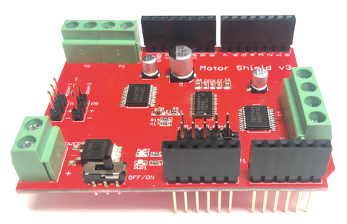 | Motor Shield | Issues:  Is connected to I2C( Need to jump cables)  Has an allcall address of 0x70, which conflicts with the multiplexer. | Documentation  https://learn.carobot.ca/guide/motor-shield-v3
TCA9548A qwiic mux  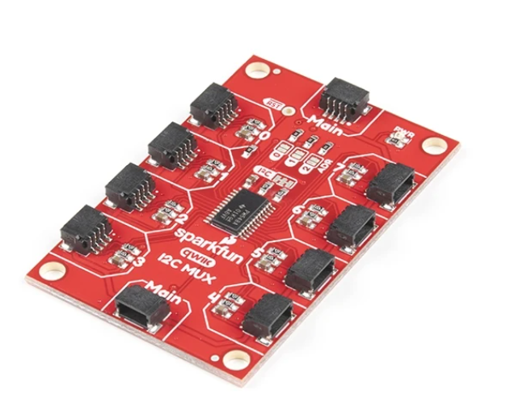 | I2C multiplexer | Address conflicts with Carobot.  Pins get easily deformed | https://cdn.sparkfun.com/assets/f/0/4/b/3/tca9548a.pdf
BNO055 absolute orientation sensor  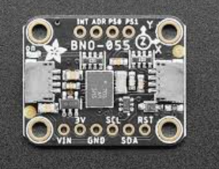 | IMU | The sensor has no reset: the heading is always global.  The sensor has a 360 degree wraparound, which is sensitive to fluctuations. | https://cdn-shop.adafruit.com/datasheets/BST_BNO055_DS000_12.pdf  code:https://adafruit.github.io/Adafruit_BNO055/html/class_adafruit___b_n_o055.html
VL53L0X TOF sensor  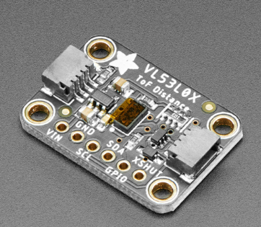 | TOF Lidar | The sensors I2C address is 0x29, which conflicts with TCS34725.  Can’t handle below 30mm of range | https://learn.adafruit.com/adafruit-vl53l0x-micro-lidar-distance-sensor-breakout/overview
TCS34725  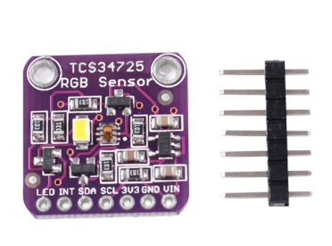 | Color sensor | Its unchangeable address conflicts with Vl53l0X.  Measurement takes 50ms | https://adafruit.github.io/Adafruit_TCS34725/html/class_adafruit___t_c_s34725.html
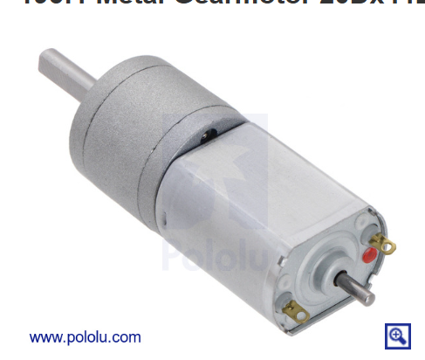  195:1 Metal Gearmotor 20Dx44L mm 12V CB with Extended Motor Shaft | Motor | Extended shaft for encoder | https://www.pololu.com/product/3493
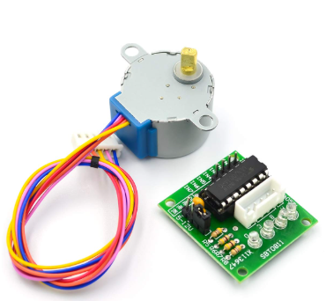 | Stepper motor | The motor itself is 5V, so you need a 5v buck. | https://lastminuteengineers.com/28byj48-stepper-motor-arduino-tutorial/
OpenMV H7 plus.  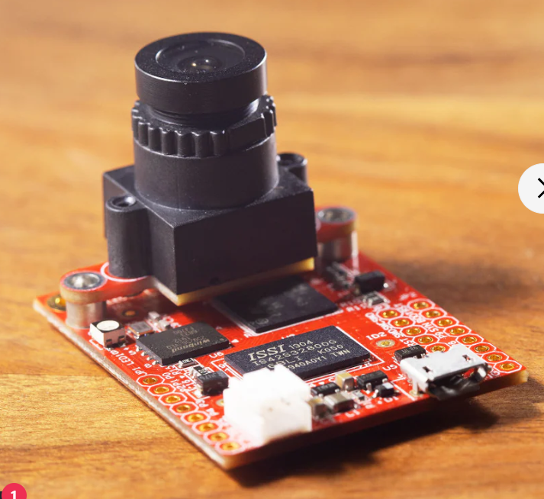 | Camera | Memory can leak from power brownouts without and SD card. | https://docs.openmv.io/library/omv.image.html
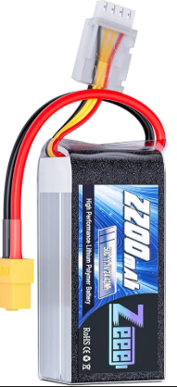 | Lipo battery | ALWAYS unplug the robot before charging.

